SIMATS ENGINEERING
ASSESSMENT TOOL 1 - Short Answer Test

COURSE NAME: COMPUTER VISION
COURSE CODE: ITA0517

COURSE OUTCOME COVERED

CO1: Apply the fundamental concepts, image formation models, and processing techniques for analyzing Computer Vision systems. (BTL 3)

Assessment Tool Weightage: 40%

QUESTIONS

1.A digital image appears distorted due to improper image formation. Identify possible causes and suggest improvements based on image formation models.

Explanation:
A digital image may become distorted due to improper focus, poor lighting, lens distortion, motion blur, or sensor noise. Image formation models improve the image by applying noise reduction, sharpening, contrast enhancement, and lens correction, resulting in a clearer and more accurate image.
Code:
import cv2
import numpy as np
import matplotlib.pyplot as plt
from google.colab import files
uploaded = files.upload()
filename = list(uploaded.keys())[0]
image = cv2.imread(filename)
image_rgb = cv2.cvtColor(image, cv2.COLOR_BGR2RGB)
denoised = cv2.fastNlMeansDenoisingColored(image, None, 10, 10, 7, 21)
kernel = np.array([[0,-1,0],
[-1,5,-1],
[0,-1,0]])

sharpened = cv2.filter2D(denoised, -1, kernel)
lab = cv2.cvtColor(sharpened, cv2.COLOR_BGR2LAB)
l, a, b = cv2.split(lab)

clahe = cv2.createCLAHE(clipLimit=2.0, tileGridSize=(8,8))
cl = clahe.apply(l)

enhanced = cv2.cvtColor(cv2.merge((cl,a,b)), cv2.COLOR_LAB2BGR)
enhanced_rgb = cv2.cvtColor(enhanced, cv2.COLOR_BGR2RGB)
plt.figure(figsize=(10,5))

plt.subplot(1,2,1)
plt.imshow(image_rgb)
plt.title("Original Image")
plt.axis("off")

plt.subplot(1,2,2)
plt.imshow(enhanced_rgb)
plt.title("Enhanced Image")
plt.axis("off")

plt.show()
cv2.imwrite("improved_image.jpg", enhanced)

print("Image enhancement completed.")

Implement: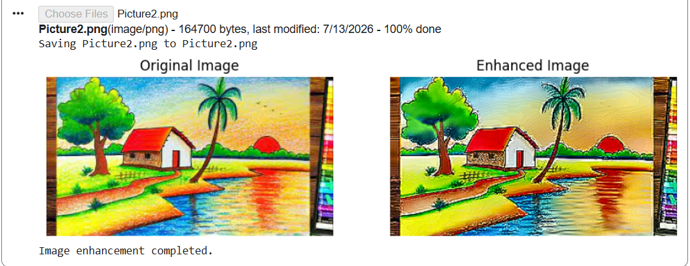

2.Explain how the features of Computer Vision systems enable applications such as automated surveillance.

Explanation
Computer Vision enables automated surveillance by detecting and tracking people in images or videos. It uses object detection, image processing, and pattern recognition to monitor areas in real time. This helps improve security, reduce manual monitoring, and automatically identify suspicious activities.
Code:
from google.colab import files
import cv2
import matplotlib.pyplot as plt

uploaded = files.upload()

filename = list(uploaded.keys())[0]
image = cv2.imread(filename)

if image is None:
print("Could not read the image.")
exit()
image = cv2.resize(image, (800, 600))
hog = cv2.HOGDescriptor()
hog.setSVMDetector(cv2.HOGDescriptor_getDefaultPeopleDetector())
boxes, weights = hog.detectMultiScale(image,
winStride=(8,8),
padding=(8,8),
scale=1.05)
for (x, y, w, h) in boxes:
cv2.rectangle(image, (x, y), (x+w, y+h), (0,255,0), 2)
image = cv2.cvtColor(image, cv2.COLOR_BGR2RGB)

plt.figure(figsize=(10,6))
plt.imshow(image)
plt.title("Person Detection")
plt.axis("off")
plt.show()

print("People detected:", len(boxes))

Implementation:
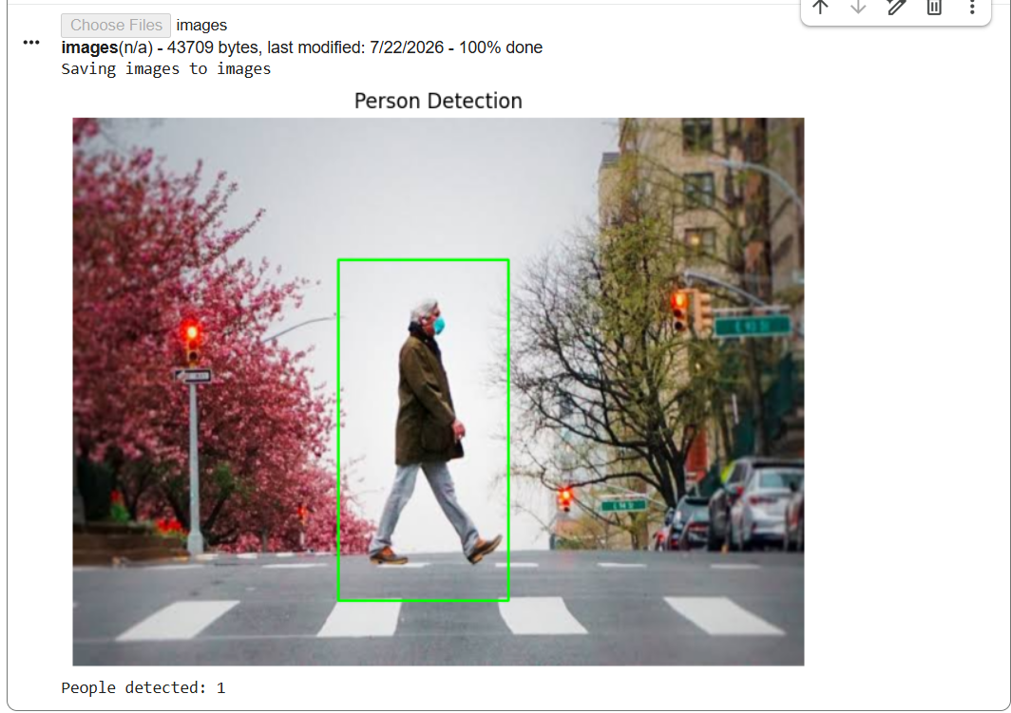

Code of Conduct:

I Yoga Madha A-192425058 (Name / Reg No) certify that this submission is my original work and that I have adhered to the guidelines specified for this assessment.
I understand that any violation of academic integrity rules will result in disciplinary action.

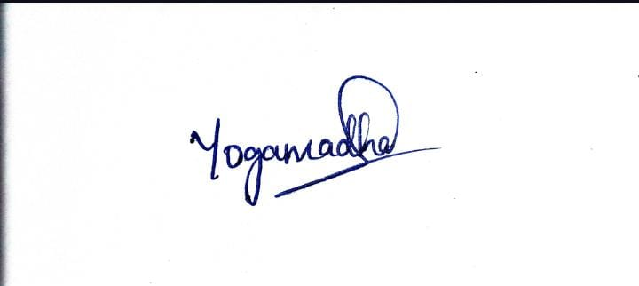
Signature of the student

